











**Board of Directors**

Genesis School, Inc. is a corporation organized under the Missouri Nonprofit Corporation Act, which is governed by a board of directors. The board is responsible for the operation of the public charter school, Genesis School. Genesis current charter agreement and performance contract is with our sponsor the Missouri Public Charter School Commission.

The board’s responsibilities include, but are not limited to:

* Governing school affairs according to law and Board policies
* Create and support the school’s mission, vision, performance objectives, policies, strategic plans
* Oversee fiscal affairs and annual budget
* Appointing and assessing the school’s leadership
* Ensuring that terms of the charter document are met
* Assure compliance with federal and state laws, including the Missouri Sunshine Law regarding public meetings and public records

Parents, Families and the public at large are invited to all public sessions of the board. A calendar of meetings and information about the board is available <https://genesisschool.org/District/Department/31-School-Board>

**ADMINISTRATION**

Executive Director Kevin Foster

Principal Vincent Wright

Dean of Students Jordan Rice

**Mission Statement**

Endow students with the knowledge, skills, and mindsets necessary to be successful in college preparatory high schools.

**Vision Statement**

Transform the Kansas City educational landscape by demonstrating that all students in an open-enrollment community school can achieve at the highest levels.

**Our Core Beliefs**

* All students can learn at high levels, and all students deserve educational excellence. A school culture based on mutual respect, rigorous expectations, and continuous growth sets the conditions for strong academic achievement.
* Achieving our students’ potential requires continuous learning and improvement. We use data to measure our progress, and purposeful reflection and research to alter our practices.
* Character development is a critical component of education. Students who are respectful, responsible, resourceful, and responsive are prepared to lead within their communities and society at large.
* A school must be inextricably linked to the community it serves: Our students’ success benefits the community, while the community supports and informs our work. Leveraging community partnerships meets our students’ needs and ensures learning.

|  |  |  |  |  |  |
| --- | --- | --- | --- | --- | --- |
|  | | |  | | |
|  |  |  |  |  |  |
|  |  |  |  |  |  |

**ATTENDANCE and ATTENDANCE SUPPORT PROGRAM**

Regular attendance at Genesis School is defined as, at a minimum, attending **school at least 90% of the time school is in session**. Students may not miss more than 10% of school minutes (excused or unexcused).

Regular attendance at Genesis School is defined as, at a minimum, attending school at least 90% of the time school is in session. Research indicates that students who attend school less than 90% of the time are **AT-RISK** for falling behind their classmates. Genesis is held accountable for having students attend 90% of the time by the Missouri Department of Education. We are also directed by the State to develop interventions and assistance programs to help families achieve the 90% goal. Interventions at Genesis include: phone contact for absences, home visits, bus scheduling resolutions, family resources and assistance, and attendance conferences. Failure to work with the school and improve attendance will result in the school reporting a violation of **Sec. 50-243. Compulsory school attendance ordnance.** The initial citation may be dismissed after you attend Court with your child, but i**f the child continues to not attend school on a regular basis, you can be fined up to $500.**

If a student is not at school by 8:05, they begin accruing absent minutes. If your child is or will be absent, please contact the school no later than 8:15.

At 8:30, we begin to attempt to contact parents who we have not heard from nor is their student at school. If we are unable to contact the parent or guardian, Genesis may travel to residences to conduct home visits in order to check on the family, problem solve about attendance, provide assistance and resolve issues.

If, during the first quarter, a student has missed more than 5 scheduled days, or dropped below 90% attendance in any subsequent quarter, parents are notified in writing that their child’s attendance is not consistent with school policy and city statute and requesting parents contact the school to discuss improved attendance.

Ultimately, our attendance policy and support program is about the school and families successfully partnering to help students succeed. Should you have questions or concerns, please contact an administrator or the Family Resource Specialist.

.

**TARDINESS**

Daily arrival time for students is 7:45am. Any student arriving after 8:05am must accompany the student into the building and sign them in. If a parent does not accompany the student into the building the parent will be telephoned to come back to school and sign the child in.

**If a student is not at school by 8:05, they begin accruing absent minutes**. Arriving after 8:05am also means that they have missed breakfast, the school morning assembly and the beginning of critical instruction.

We want to help insure your student is on time and ready to learn. If you need assistance please contact us at 816-921-0775. For coordinating transportation, ask for the Transportation Coordinator. If you need other support or resources, please ask for the Family Resource Specialist. If you have any questions, please ask to speak to a School Administrator.

**Early Dismissals**

Staff members will not excuse a student from school before the end of the school day without a request from that student’s parent or guardian. Students must be checked out and picked up from the reception area.. If your child has excessive early dismissals, the time missed will be calculated in accumulative days and hours missed.

**Parent Pick-Up**

Your child’s safety is of the utmost importance to Genesis School. Therefore, we want to make sure your student is present during times when adult supervision is available. Parents may make arrangements for transporting their student(s) privately, including dropping students off at Genesis at the start of the school day and picking them up at the conclusion of the day. ***Students WILL NOT be released to anyone that is not on the pick-up list.*** Please make sure that the Front Office has the correct and most current information about authorized persons.

**Visitors**

All visitors are to report to the Office upon entering the building and sign-in. When a parent/ guardian needs to conference with a teacher or counselor, an appointment shall be made in advance. Groups of visitors wishing to visit the school or facility shall notify the Executive Director and/or Principal’s Office, as far in advance as possible, to arrange, and schedule a visit.

All persons who do not obtain prior permission from Executive Director or Principal’s Office to visit the School, or visitors who create distractions to the learning environment in the building or on the premises, shall be considered trespassers and subject to arrest and prosecution.

**REQUIREMENTS FOR ENROLLMENT**

**(Student must reside within the Kansas City MO School District’s boundaries to attend)**

1. Original Birth Certificate. Photo copies are not acceptable.
2. Required immunizations by a doctor upon entering school the opening day.
3. Proof of residence. (i.e. – utility bill, lease agreement, etc.)

These records must be turned in on or before the first day of school. Students who are not in compliance with these requirements may be excluded from school until everything is completed.

**Immuinzation Exemptions:**

Medical Exemption: A student shall be exempted from the immunization requirements of this rule as provided in section 167.181, RSMo, upon signed certification by a licensed doctor of medicine (MD), doctor of osteopathy (DO), or his or her designee indicating that either the immunization would seriously endanger the student's health or life or the student has documentation of disease or laboratory evidence of immunity to the disease.

Religious exemption. A student shall be exempted from the immunization requirements of this rule as provided in section 167.181, RSMo, if one (1) parent or guardian objects in writing to the school administrator that immunization of that student violates his/her religious beliefs.

For exemptions to the immunization requirement, contact the school nurse.

**Bus Transportation**

Student Transportation of America provides bus transportation for Genesis students, and should be contacted directly with any concerns or problems 816-418-8961. Genesis will assist parents/guardians in resolving any bus concerns with STA. There is a bus agreement that every parent and student must complete in order to be placed on a bus. If you should wish to change the means of transportation for the student, please call by 1:00 pm on that day or send a note with your child. If there are any changes to bus stops or change of address, please contact the school directly.

***Please remember any time your student is at school longer than 10 minutes and no notification has been made to the school, emergency contacts will be called. If no one responds, authorities may be contacted to pick up your child from school.***

**School Closing Information**

In case of severe weather or other emergencies, parents and guardians should check the school’s website

([www.genesisschool.org](http://www.genesisschool.org)), social media, and watch the four primary Kansas City television stations* to see if ***Genesis School*** is listed. The Executive Director will determine whether to close school based on the best available information regarding weather and bus travel. If it becomes necessary to dismiss classes during the day, the local television and radio stations will be alerted. We will call families if schools are dismissing early. Parents are responsible for providing the front office and their students' teachers with accurate, current telephone and email contact information. If parents are not home during the day, they should talk to their students so they have a plan of where to go in the event of an emergency dismissal.

If a tornado or other severe storm alert is broadcast, students will not be dismissed until the "all clear" signal has been given.

* Primary media stations include:

WDAF-TV 4 KCMO-TV 5 KMBC-TV 9 KSHB-TV 41

**School Breakfast and Lunch**

Genesis School participates in the CEP program and provides breakfast and lunch to all of their students regardless of status. Parents that wish to send their students with a sack lunch, it must be a healthy complete lunch that includes all of the food groups. If you need assistance with picking healthy options for your child’s lunch, please do not hesitate to contact the school nurse.

**Student Transcripts and Academic Records**

A cumulative educational record shall be maintained for each student from his/her entrance into school through the last date of attendance and kept on file in accordance with State law. Each student’s educational record will include information required by state and federal statutes, regulations or agencies and shall include other information deemed necessary by school officials. The parents/guardians of (minor) students who are attending or have attended Genesis School have the right to inspect and review the educational records of their students and to request amendment of their students’ educational records. Except as otherwise required, in compliance with the Individuals with Disabilities Act or Section 504 of the Rehabilitation Act of 1973, records containing student health information will be stored separately from other student records. Student academic progress can be monitored through Infinite Campus.

**MOCAP**

The Missouri course access and virtual school program offers instruction in a virtual setting using technology, intranet, and/or internet methods of communication. Any student under the age of twenty-one in grades kindergarten through twelve who resides in this state shall be eligible to enroll in the Missouri course access and virtual school program pursuant to subsection 3 of this section.

For additional questions about MOCAP enrollment, contact Karen McClish at 816-921-0775. More information is also available at <https://mocap.mo.gov/>.

**Parent-Teacher Conferences**

Parent-Teacher Conferences are scheduled two times throughout the school year. It is required that parents/guardians contact their child’s teacher(s) in advance to schedule their conference. In addition to Parent-Teacher Conferences, parents/guardians are encouraged to contact the principal or student’s teachers if they have any questions or concerns regarding their child’s academics and/or behavior during the school year.

**Promotion Standards and Retention Policy**

Students must be recommended for promotion by the student grade level team to the instructional leadership team based on the satisfactory classroom performance throughout the current school year. (Note: The final approval must be approved by Genesis School Administration.)

**Withdrawing Students**

If a parent/guardian wishes to withdraw their student from Genesis School, the parent/guardian shall contact the Front Office for the necessary paperwork.

**Special Education Services**

Students that need special services are referred by teachers for academic intervention. Parents may also request a referral for their child. If it is determined that the child needs special services then they are placed into a special education program. Genesis School is a full inclusion school which means that students with Individual Education Plans (IEP) are placed in classrooms with general education teachers and students. Whenever possible, students with IEPs are serviced within the general education classroom by Special Education Teachers.

**Internet Usage Policy and Technology Agreement**

Students will receive instruction in the proper and acceptable use of technology while at school. Each student will be held accountable for failing to adhere to the technology policy requirements.

Genesis School will monitor student use of school technology. Pursuant to State and Federal law, Genesis School has access to all communications sent, received or stored by any student using the school’s technology resources, and may monitor student online activity that takes place utilizing school equipment or Internet network. Genesis employs Securly, in order to block/filter student access to inappropriate Internet materials, without intentionally restricting students’ access rights to controversial and educational materials under the First Amendment.

Genesis School retains the right to restrict or extinguish students’ access and use of the school's technology if it is determined that the student has not abided by the school’s technology use policies. A student’s parent/guardian will be held responsible for any damage or unauthorized costs that arise from a student’s inappropriate use of school’s equipment or other technology resources. A complete copy of the Genesis School technology use guidelines is available.

**Media Policy**

Throughout the year, Genesis School will publish student photographs, video and/or audio clips, student quotes, and student writing and artwork, which have been deemed “Directory Information.”

The Family Educational Rights and Privacy Act (FERPA), a federal law, requires that Genesis School, with certain exceptions, obtain written consent from a parent/guardian prior to disclosure of personally identifiable information from your child’s educational record. Genesis School **may** disclose appropriately designated “Directory Information” **without** written consent, unless you have advised the district to the contrary. As stated above, the primary purpose of Directory Information is to allow Genesis School to include certain information about your child in school publications.

If you do not want Genesis School to disclose Directory Information from your child’s education record without your prior written consent, you may **opt-out** with written notice.

**Dress Code Policy**

While no longer requiring uniforms, in order to create a productive, 4R learning environment for all, the following general guidelines should be considered when dressing for school.

Genesis School will be following a casual dress code for our students. Jeans and sneakers are appropriate. Students may also opt to wear khakis, cargos, polo shirts. Other options include comfortable t-shirts or blouses, cardigans, or a blazer.

Please avoid:

* + Clothing with vulgar words, sayings or illustrations on them
  + Hats
  + Clothing with tobacco, drugs, alcohol, or weapons represented
  + Clothing that promotes racism, or is considered offensive
  + Pants that fall below the waistline
  + Any clothing that can pose a distraction in class
  + Clothing that is unsafe (such as those that pose a tripping hazard, etc.)
  + Costume attire or theatrical make-up
  + Shirts or tops that do not cover the midriff, back or chest area
  + Students must wear shoes with hard soles while at school. No slippers.
* Genesis Swag wear such as fleece jackets are available to purchase.

If a question is raised about a student's choice of dress, Genesis School administration will be contacted. A student may be asked to change into available appropriate clothing, or parents will be notified for assistance.

**Telephone and Cell Phone Usage**

Students are not permitted to make phone calls except in cases of emergency or by teacher request. Students who need to use the telephone must have approval from their teacher. Cell phones are not allowed to be used in the building. Students bringing cellphones to school must be out of sight and keep them there until the end of the school day. Cell phones are to be turned off upon entering the building and are to remain off until after dismissal. Cell phones seen, used, or heard (includes text messaging) during the day will be confiscated and returned by the end of the day, for the second infraction the phone will be confiscated and a parent will need to pick up the cell phone. Using a cell phone to take pictures or audio/video recording is not allowed during the school day, on school transportation, or at any school events that occur during the school day.

Cell phones are not the responsibility of the faculty and staff at Genesis School. Students who disregard the cell phone policy are subject to discipline as outlined in the Genesis School Discipline Policy. **Please do not call or text your child’s cell phone**, since it is against school policy for students to use them during school hours.

**BEHAVIOR EXPECTATIONS**

**4R EXPECTATIONS**

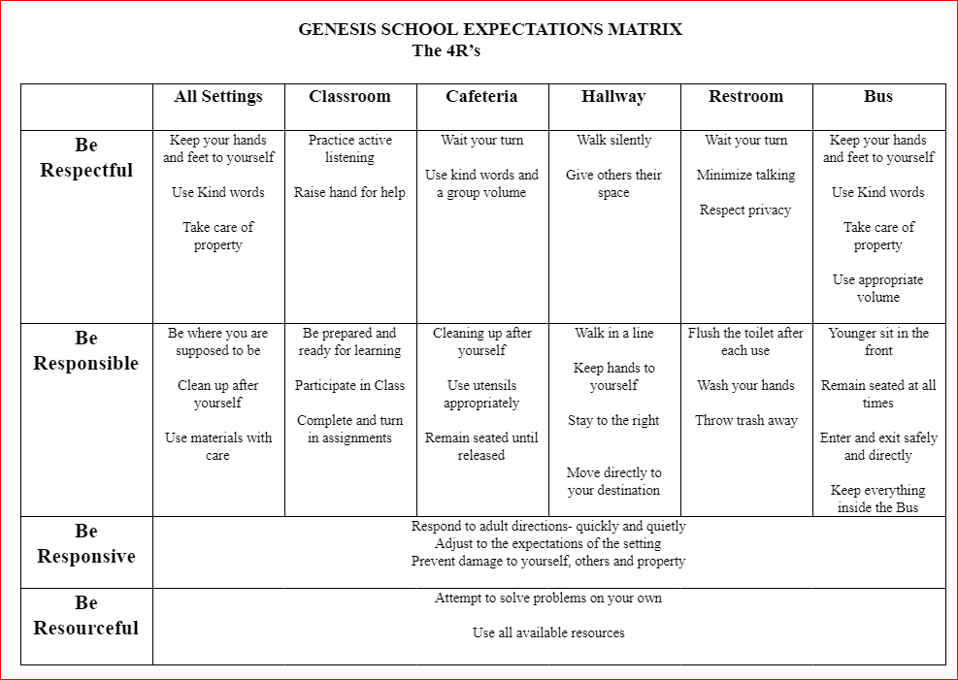

**SUSPENSION/ EXPULSION**

A student may be suspended for a period up to ten days for gross disobedience or misconduct. Make-up work will be provided at the teacher’s discretion.

**SAFE SCHOOL VIOLATIONS**

If a student violates the Missouri Safe School Violations or Class IV offense, the student may be subject to the following:

1. Long-Term suspensions (Up to 180 days suspension) or
2. Expulsion from Genesis School

**STUDENT CONDUCT**

Genesis School strictly prohibits any form of bullying or intimidation by students toward school personnel or students on school grounds, at a school sponsored activity, on a school bus, or in a school related context. Genesis School defines bullying as an intentional action by an individual or group of individuals to inflict physical, emotional or mental suffering on another individual or group of individuals. Bullying shall include any intentional gesture, written, verbal, or physical threat severe enough to create an abusive atmosphere in the learning environment. This includes:

* Communicates with another by any means including, but not limited to: face to face, telephone, writing, electronic communications, or Internet postings with the intention to intimidate or inflict physical, emotional or mental harm without legitimate purpose, or
* Physical contact with another person with the intent to intimidate or to inflict physical, emotional or mental harm.

Consequences may include suspension from school and/or an expulsion hearing referral, depending on the frequency and severity of the incident.

**Bullying**

**What is Bullying?**

Aggressive behavior may be bullying depending on what happened, how often it happens and who it happens to. Find out what bullying is and what the different types are. You can also learn more about other topics related to bullying.

**Bullying Definition**

Bullying is unwanted, aggressive behavior among school aged children that involves a real or perceived power imbalance. The behavior is repeated, or has the potential to be repeated, over time. Bullying includes actions such as making threats, spreading rumors, attacking someone physically or verbally, and excluding someone from a group on purpose.

**Harassment Definition**

Although bullying and harassment sometimes overlap, not all bullying is harassment and not all harassment is bullying. Under federal civil rights laws, harassment is unwelcome conduct based on a protected class (race, national origin, color, sex, age, disability, religion) that is severe, pervasive, or persistent and creates a hostile environment.

**Genesis School Bullying/Harassment Policy 2655**

Genesis is committed to maintaining a learning and working environment free of any form of bullying or intimidation by students toward Genesis personnel or students on school grounds, or school, at a school sponsored activity or in a school related context.

***"Bullying" means intimidation, unwanted aggressive behavior, or harassment that is repetitive or is substantially likely to be repeated and causes a reasonable student to fear for his or her physical safety or property; substantially interferes with the educational performance, opportunities, or benefits of any student without exception; or substantially disrupts the orderly operation of the school.*** Bullying may consist of physical actions, including gestures, or oral, cyber bullying, electronic, or written communication, and any threat of retaliation for reporting of such acts.

Bullying of students is prohibited on school property, at any school function, or on a school bus. "Cyber bullying" means bullying through the transmission of a communication including, but not limited to, a message, text, sound, or image by means of an electronic device including, but not limited to, a telephone, wireless telephone, or other wireless communication device, computer, or pager.

**Reporting**

At Genesis, the person you will need to report any/all acts of bullying to is the Dean of Students.

Any school employee who has knowledge of an incidence of bullying is required to report it to the Dean of Students within **2 school days** of observing or learning of the act.

**Investigating**

Within 2 school days of a report of an incident of bullying being received, the Principal or their designated administrator shall initiate the investigation of the incident.

The investigation must be completed within 10 school days from the date of the report (unless there is a valid reason to extend this timeline), all students/staff involved in the investigation will be informed that reprisal or retaliation against any person who reports an act of bullying is prohibited and will result in disciplinary action

**Follow Up**

Upon the conclusion of the investigation and resolution of the incident the administrator leading the investigation will follow up with the victim on the following schedule:

* + *5 days after resolution*
  + *10 days after resolution*
  + *30 days after resolution*

All Follow-up conversations will be documented

Students who are found to have violated this policy will be subject to the following consequences depending on factors such as: age of student(s), degree of harm, severity of behavior, number of incidences, etc. Consequences: Loss of privileges, classroom detention, conference with teacher, parents contacted, conference with Principal, in-school suspension, out-of-school suspension, and expulsion and law enforcement contacted.

**Training**

Genesis will provide training for employees relative to enforcement of this policy.

**Please reference:**

**Missouri State Law on Anti-Bullying**

**DESE website-** <https://dese.mo.gov/governmental-affairs/public-school-laws-missouri/bullying>

## **SEXUAL HARASSMENT**

Sexual harassment of students is prohibited. Any person, including a School employee, agent, third party, or student engages in sexual harassment whenever he/she does any of the following, but not limited to: makes sexual advances, requests sexual favors, and engages in other verbal or physical conduct of a sexual or sex-based nature that interferes with a student’s educational environment, or creates an intimidating, hostile, or offensive education environment.

Students who believe that they are victims of sexual harassment or have witnessed sexual harassment, are encouraged to, and should, discuss the matter with the principal, Dean of Students or counselor so that the School can investigate the allegation of harassment and, if appropriate, take responsive measures.

Students who make good faith complaints will not be disciplined. However, any person making a knowingly false accusation regarding sexual harassment will be subject to disciplinary action up to and including suspension and expulsion.

**Non-Discrimination on the Basis of**

**Race, Ethnicity, Disability, Religion, or Gender**

The Board reaffirms its belief that every student regardless of race, creed, color, sex, cultural, or socioeconomic status or disabling condition be given equal opportunity for educational development. The Board is committed to providing an educational environment free from unlawful harassment. Specifically, the school and its employees shall not participate in any harassment based on gender, race, or nationality or other basis impermissible under the law. Further, no student shall be allowed to participate in any harassment based on gender, race, or nationality or other basis impermissible under the law.

## **CONDUCT ON SCHOOL BUSES**

Students shall abide by the general school rules regarding conduct on school property. In cases of gross disobedience or misconduct, a student's privilege to ride the bus may be suspended and/or denied. During the period of suspension, it is the responsibility of the parent or guardian to transport the student to school.

Levels of offenses and consequences are as follows:

|  |  |  |
| --- | --- | --- |
| **Level I Offenses** | **Level II Offenses** | **Level III Offenses** |
| Standing while the bus is in motion | Disrespect | Assault |
| Changing seats | Inappropriate language | Verbal Threat – Staff |
| Not staying in seat | Reckless behavior/horseplay | Jeopardizing the safety of others |
| Excessive noise | Verbal Threat – Peers | Vandalism |
| Eating – Drinking – Littering | Name calling | Fighting |
| Riding unassigned bus or using an unassigned stop | Bullying/Intimidation/Harassment of peers | Drugs/Alcohol |
| Other (Explain) | Non-compliant (will not follow direction from driver and/or monitor) | Tobacco/smoking on bus |
| Throwing (things in/out of bus) | Weapons |
| Verbal Abuse – Staff | Arson/Combustibles |

|  |  |
| --- | --- |
| **Level of Offense** | **Consequences** |
| **I** | 1st offense: Student Warning Conference  2nd offense: Warning; In School Consequence  3rd offense: 1 – day bus suspension  4th offense: 3 – day bus suspension  5th offense: 5 – day bus suspension, Parent conference  6th offense: Suspension from bus, subject to cancellation of bus service |
| **II** | 1st offense: Written warning or 1 – 3 day bus suspension  2nd offense: 3 – 5 day bus suspension  3rd offense or more: 5 – day bus suspension or possible extended loss of bus privileges |
| **III** | 1st offense: 1 – 5 day bus suspension  2nd offense: 5 – 10 day bus suspension  3rd offense or more: Extended loss of bus privileges |

STA reserves the right to install and operate video cameras on school buses as they deem appropriate. Evidence gathered by the use of a video camera and/or its auditory recording equipment may be used in student disciplinary investigations and/or any pertinent criminal investigations.

**SCHOOL VISITATION**

Adult visitors are always welcome to visit Genesis School, while following COVID-19 safety protocols. All visitors must report to the office upon arrival. A staff member must accompany all adult visitors.

Parental interruptions are not permitted during school hours. Classroom visits are a time for observation only; they can establish an excellent background for parent-teacher conferences. **All classroom observations must be scheduled through the Principal 24 hours ahead of time.**

Individual parent conferences may be arranged by contacting the school at 816-921-0775.

**EVERY STUDENT SUCCEED ACT OF 2015**

For any student attending a school receiving Title I funds, the district will, at the parent’s or guardian’s request, provide information regarding the professional qualifications of a student’s teacher consistent with applicable legal requirements. Upon your request, the district is required to provide to you in a timely manner the following information:

* when the teacher has met state qualification and licensing criteria for the grade levels and subject areas in which the teacher provides instruction;
* whether the teacher is teaching under emergency or other provisional status through which state qualification or licensing criteria have been waived;
* whether your child is provided services by paraprofessionals and, if so, their qualifications; and
* what baccalaureate degree major of the teacher and any other graduate certification or degree held by the teacher and the field of discipline of the certification.

In addition to the information that parents and/or guardians request, the district must provide to each individual parent or guardian the following information:

* Information on the achievement level of the parent’s or guardian’s child in each of the state academic assessments, as required under this part; and
* Timely notice that the parent’s or guardian’s child has been assigned or has been taught for four (4) or more consecutive weeks by a teacher who is not highly qualified.

**Missouri Department of Elementary and Secondary Education**

**Every Student Succeeds Act of 2015 (ESSA) COMPLAINT PROCEDURES**

This guide explains how to file a complaint about any of the programs that are administered by the Missouri Department of Elementary and Secondary Education (the Department) under the Every Student Succeeds Act of 2015 (ESSA)2.

|  |  |
| --- | --- |
| **Missouri Department of Elementary and Secondary Education Complaint Procedures for ESSA Programs**  **Table of Contents** | |
| **General Information**   1. What is a complaint under ESSA? 2. Who may file a complaint? 3. How can a complaint be filed? | |
| **Complaints filed with LEA**   1. How will a complaint filed with the LEA be investigated? 2. What happens if a complaint is not resolved at the local level (LEA)? | **Complaints filed with the Department**   1. How can a complaint be filed with the Department? 2. Are complaints related to equitable services to nonpublic school children handled differently? 3. How are complaints related to equitable services to nonpublic school children handled differently? |
| **Appeals**   1. How will appeals to the Department be investigated? 2. What happens if the complaint is not resolved at the state level (the Department)? | |

1. **What is a complaint?**

For these purposes, a complaint is a written allegation that a local education agency (LEA) or the Missouri Department of Elementary and Secondary Education (the Department) has violated a federal statute or regulation that applies to a program under ESSA.

1. **Who may file a complaint?**

Any individual or organization may file a complaint.

1. **How can a complaint be filed?**

Complaints can be filed with the LEA or with the Department.

1. **How will a complaint filed with the LEA be investigated?**

Complaints filed with the LEA are to be investigated and attempted to be resolved according to the locally developed and adopted procedures.

1. **What happens if a complaint is not resolved at the local level (LEA)?**

A complaint not resolved at the local level may be appealed to the Department.



*1 Programs include Title I. A, B, C, D, Title II, Title III, Title IV.A, Title V* Revised 4/17

*2 In compliance with ESSA Title IX Part C. Sec. 8304(a)(3)(C)*

*Local education agencies are required to disseminate, free of charge, this information regarding ESSA complaint procedures to parents of students and appropriate private school officials or representatives.*

1. **How can a complaint be filed with the Department?**

A complaint filed with the Department must be a written, signed statement that includes:

* 1. A statement that a requirement that applies to a ESSA program has been violated by the LEA or the Department, and
  2. The facts on which the statement is based and the specific requirement allegedly violated.

1. **How will a complaint filed with the Department be investigated?**

The investigation and complaint resolution proceedings will be completed within a time limit of forty-five calendar days. That time limit can be extended by the agreement of all parties.

The following activities will occur in the investigation:

* 1. **Record.** A written record of the investigation will be kept.
  2. **Notification of LEA.** The LEA will be notified of the complaint within five days of the complaint being filed.
  3. **Resolution at LEA.** The LEA will then initiate its local complaint procedures in an effort to resolve the complaint at the local level.
  4. **Report by LEA.** Within thirty-five days of the complaint being filed, the LEA will submit a written summary of the LEA investigation and complaint resolution. This report is considered public record and may be made available to parents, teachers, and other members of the general public.
  5. **Verification.** Within five days of receiving the written summary of a complaint resolution, the Department will verify the resolution of the complaint through an on-site visit, letter, or telephone call(s).
  6. **Appeal.** The complainant or the LEA may appeal the decision of the Department to the U.S. Department of Education.

1. **Are complaints related to equitable services to nonpublic school children handled differently?**

In addition to the procedures listed in number 7 above, complaints related to equitable services will also be filed with the U.S. Department of Education, and they will receive all information related to the investigation and resolution of the complaint. Also, appeals to the United States Department of Education must be filed no longer than thirty days following the Departments’ resolution of the complaint (or its failure to resolve the complaint).

1. **How will appeals to the Department be investigated?**

The Department will initiate an investigation within ten days, which will be concluded within thirty days from the day of the appeal. This investigation may be continued beyond the thirty day limit at the discretion of the Department. At the conclusion of the investigation, the Department will communicate the decision and reasons for the decision to the complainant and the LEA. Recommendations and details of the decision are to be implemented within fifteen days of the decision being delivered to the LEA.

1. **What happens if a complaint is not resolved at the state level (the Department)?**

The complainant or the LEA may appeal the decision of the Department to the United States Department of Education.

Public Complaints/Concerns

A complaint is a formal allegation that a specific federal or state law or regulation had been violated, misapplied, or misinterpreted by school district personnel or by Department of Education personnel.

Any parent or guardian, surrogate parent, teacher, administrator, school board member, or other person directly involved with an activity, program, or project operated under the general supervision of the Department of Education may file a complaint. Such a complaint must be in writing and signed; it must provide specific details of the situation and indicate the law or regulation that is allegedly being violated, misapplied, or misinterpreted. The written, signed complaint must be filed and the resolution pursued in accordance with local district policy.

The policy of Genesis School is as follows:

*Although no member of the school community shall be denied the right to petition the Board for redress of a grievance, the complaints will be referred through the proper administrative channels for resolution before investigation or action by the Board. Exceptions are complaints that concern Board actions or operations only. The Board advises the school community that the proper channeling of complaints involving instruction, discipline, or learning materials is as follows:*

1. *Teacher*

2. *Principal*

3. *Superintendent/Executive Director (or designee)*

4. *Board*

*Any complaint about school personnel will be investigated by the Administration before consideration and action by the Board.*

If the issue cannot be resolved at the local level, the complainant may file a complaint with the Missouri Department of Elementary and Secondary Education. If there is no evidence that the parties have attempted in good faith to resolve the complaint at the local level, the Department may require the parties to do so and may provide technical assistance to facilitate such resolution. Any persons directly affected by the actions of the Department may file a similarly written complaint if they believe state or federal laws or regulations have been violated, misapplied, or misinterpreted by the Department itself. Anyone wishing more information about this procedure of how complaints are resolved may contact local district or Department

personnel.

*\*Please note: Parents of any student attending a school receiving Title I Funds may request information regarding the professional qualifications of the student’s classroom teachers.*

**Public Notice**

All responsible public agencies are required to locate, evaluate, and identify children with disabilities who are under the jurisdiction of the agency, regardless of the severity of the disability, including children attending private schools, highly mobile children, such as migrant and homeless children, and children who are suspected of having a disability and in need of special education even though they are advancing from grade to grade. Genesis School assures that it will provide a free, appropriate public education (FAPE) to all eligible children with disabilities between the ages of 3 and 21 under its jurisdiction. Disabilities include autism, deaf/blindness, emotional disorders, hearing impairment and deafness, mental retardation, multiple disabilities, orthopedic impairment, other health impairments, specific learning disabilities, speech or language impairment, traumatic brain injury, visual impairment/blindness and young child with a developmental delay. Genesis School assures that it will provide information and referral services necessary to assist the State in the implementation of early intervention services for infants and toddlers eligible for the Missouri First Steps program. Genesis School further assures that personally identifiable information collected, used, or maintained by the agency for the purposes of identification, evaluation, placement, or provision of FAPE of children with disabilities may be inspected and/or reviewed by their parents/guardians. Parents/guardians may request amendment to the educational record if the parent/guardian believes the record is inaccurate, misleading, or violates the privacy or other rights of their child. Parents have the right to file complaints with the U.S. Department of Education or the Missouri Department of Elementary and Secondary Education concerning alleged failures by the district to meet the requirements of the Family Educational Rights and Privacy Act. Genesis School has developed a Local Compliance Plan for the implementation of State Regulations for the Individuals with Disabilities Education Act (IDEA). This plan contains the agency’s policies and procedures regarding storage, disclosure to third parties, retention, and destruction of personally identifiable information and the agency’s assurances that services are provided in compliance with the General Education Provision Act (GEPA). This plan may be reviewed in the Principal's Office between 9:00 A.M. and 4:00 P.M., Monday through Friday. This notice will be provided in native languages as appropriate.

**NOTICE PROVISION OF THE FAMILY EDUCATIONAL**

**RIGHTS AND PRIVACY ACT (FERPA)**

Genesis School is mandated to inform each parent/guardian or eligible student that “Directory Information” may be released by school officials, including print and electronic publications of the district. Such information is also considered a “public record,” which must be released upon demand to any person who requests it under the Missouri Sunshine Law. “Directory Information” is information designated by the District which, if disclosed, would not generally be considered harmful or an invasion of privacy. Genesis School designates the following items as Directory Information:

**1. Students in Kindergarten through Eighth Grade**

Student’s name; parent’s name; date of birth; grade level; bus assignment; enrollment status (e.g., full-time or part-time); participation in school-based activities and sports; weight and height of members of athletic teams; dates of attendance; honors and awards received; artwork or coursework displayed by the district; most recent previous school attended; and photographs, videotapes, digital images and recorded sound unless such photographs, videotapes, digital images and recorded sound would be considered harmful or an invasion of privacy.

#### Reporting Child Abuse

State law requires that any school employee who knows or has reasonable cause to suspect that a child has been subjected to abuse or neglect, or observes the child being subjected to conditions which would reasonably result in abuse or neglect must immediately report or cause a report to be made to the Missouri Division of Family Services.

**SCHOOL INFORMATION AND PROCEDURES**

**ARTICLES PROHIBITED AT SCHOOL/PERSONAL PROPERTY**

Certain articles are prohibited at school because of safety factors. These include: knives, league baseballs, slingshots, and weapons, look-like weapons, matches, lighters, pagers, rubber bands, glass bottles and laser pointers. Possession or use of a weapon or any other object that might be considered a weapon or used as a weapon is prohibited and will result in a suspension.

Other articles which are valuable such as toys, MP3 players, money, jewelry, and hand- held video games may be brought to school only on special occasions and only with the teacher’s permission.

Candy and gum chewing are prohibited in the classroom and on the school grounds. Students are not allowed to bring cameras to school or on field trips. Students are not allowed to photograph other students due to parent permission being needed for all media.

Please assist us by helping your child understand the need for such rules.

**CHANGE OF ADDRESS AND TELEPHONE NUMBERS**

Parents should notify the school of any change of address, place of employment, home telephone, or the change of any emergency information. This is extremely important in locating you in case of any emergency. This information is needed for the health and safety of your child. If your child is seriously ill and we have no contacts we will dial 911.

**FIELD TRIPS**

Field trips are intended to enhance the school curriculum and offer students unique learning opportunities. Clearly defined expectations will be communicated to students and parents. All student field trips are paid for by Genesis School, **unless otherwise indicated**. All field trips are pre-approved by the Principal. Transportation is arranged by an approved bus company. If needed, parents may be asked to chaperone by the classroom teacher, however, parents must have attended the approved Genesis Volunteer Training Workshop. This provides additional supervision when students are outside of school property. Students who frequently demonstrate inappropriate behavior will not be allowed to attend field trips at the teacher’s and/or administrator’s discretion. **For students who are not attending field trips, trip days are a regular school day and they are to report to school. If students fail to report to school the absence is unexcused.**

**HEALTH SERVICES**

**NURSE**

Genesis School has a nurse on duty. She may speak with students, teachers and parents regarding health problems. Students requiring health or first aid services should report to the main office for assistance. A nurse or designee will always be around for an emergency.

Parents can assure their child’s effectiveness at school by providing good nutrition, adequate rest, and cleanliness, medical and dental care. Please be sure the school registration sheet for your child contains a current emergency phone number.

**MEDICATION**

Students are not to have medication in their possession during the school day. All medicines, properly labeled by the pharmacy, must be left in the main office. Medicines are defined as over-the-counter (aspirin, decongestants, cough drops, etc.), and registered prescription drugs. We are unable to comply with any requests to administer medication unless both parent and physician have completed the proper form(s). This form includes the physician’s written order for medication and the parent’s request to administer medication at school. You can request this form in the school’s main office. **No medicine will be dispensed and/ or administered by school personnel until all completed forms are returned. This includes prescriptions, aspirin, cough medicine, inhalers, etc.**

**STUDENT INJURIES**

Students report to the office for an injury. The office may only apply ice or a bandage to an injury. Parents will be contacted in the event of a serious injury. It is very important that you inform the office of correct telephone numbers in case of an emergency. An accident report will be completed by the supervising adult and placed on file. If a serious injury occurs and no contacts are available 911 will be dialed.

**ACCIDENT AND ILLNESS**

The school will make every effort to inform the parents of any accident or illness occurring at school that may need care or observation from home. Every accident that occurs in the school building, on school grounds, during any event sponsored by the school must be reported immediately to the person in charge of the activity and to the school office.

Students who become ill at school will be sent home only after a parent or someone at the emergency number on the registration card is contacted. Therefore, **it is very important that the school has valid emergency phone numbers on file.**

If a child has a temperature of 100 degrees or higher, he/she will be sent home and must stay out until they are fever free for **24 hours without medication before returning to school**. Children who vomit while at school will be sent home and must stay out for **24 hours before returning to school.**

**HOME PRACTICE (HOMEWORK)**

Genesis School is committed to the concept that supervised study during each class is most productive in terms of time and effort. Home practice should supplement and reinforce what has been taught in the classroom. Some students may need additional practice in some skills taught. For other students, home practice is a means of completing school activities started in class. Students who have fallen behind because of extended absences will need to complete missed assignments to catch up with the class. Parents can assist their child by providing a quiet place for study, showing interest and encouraging students to assume the responsibility for their work. After written homework is completed, studying with an adult is suggested.

Students are expected to take home all necessary supplies at 3:10p.m. and are not allowed back into the building after they are dismissed.

**SANKOFA SCHOLAR FRIDAYS**

Flexible days were built into the calendar in order to provide flexibility when meeting the unique demands of the school year. Primarily designed as potential make-up days for closure as well as opportunities to address staff development needs, it is our intent to provide Sankofa Scholar programming on flexible days. Regular school bus transportation will be provided on all flex days (regular morning and end of school bus runs 7:50 arrival and 3:05 departure, but not the 4:45 activity bus) as well as food service provided by the Boys and Girls club. Students may also leverage transportation on flexible days to take advantage of Boys and Girls club programming as available.

**MEDIA RELEASE**

Occasionally the local newspaper, radio station or television station may cover an event at school. While doing so, students may be interviewed or photographed. If you DO NOT want your child to participate in such activities, you must notify the school in writing stating this. The school will keep the notice on file for the school year. Notification must be updated yearly. **You must sign the media release for your child’s name to appear in the newspaper for student of the month or honor roll.**

**RECESS**

During the school year, students may be going outside for recess. All students K – 5th grades may go out and are expected to dress appropriately. If your child cannot go out because of recent illness, we must have a doctor’s note stating why he or she cannot participate in outside recess activities. If no doctor’s note is received, the student is expected to participate in outside recess.

**RELIGIOUS OBJECTIONS**

Particular religious beliefs sometimes conflict with state or school policies and procedures. In order for a child to be excused from such policies, a written note stating the religious objection must be on file in the Principal’s office and a copy given to the classroom teacher. Various holidays such as Christmas, Halloween, and Valentine’s Day are celebrated with small room parties. In order to be excused from these types of activities, the note must be on file.

**SAFETY**

***To and From School*** – Parents are encouraged to review common safety rules for their children who walk to and from school. Children should use the sidewalks wherever possible, cross at corners only using the cross walks, walk facing the oncoming traffic, obey school staff members and go straight to their destination without stopping to play.

***Transported Children* –** Parents can help children grow in good safety habits by dropping off and picking up children in the parent pick up line only. Children should exit and enter cars from the passenger side. Please respect students who are walking and crossing the street. Students are to be dropped off and picked up at the front of the building, which is the new shared entrance with Boys and Girls Club.

Drivers are not to pull around stopped cars or busses when dropping off or picking up children. Many times children are crossing from both sides of the street and many drivers can not see small children crossing.

Students are not to cross the street in front of school unless an adult crosses them. This is for everyone’s safety.

***Playground*** – Children may not cross the street to chase a ball or other object, or to play, without the permission of the adult supervisor. Playground equipment is available for their enjoyment but must be properly utilized. Caution should be exercised when using balls, ropes and other playground equipment.

In general, all students must be in supervised areas at all times. No student is permitted to do anything that is harmful to them, to others, or to school property any time.

We are concerned about the safety of children and need the support of all parents in teaching safety habits.

**STUDENTS TRANSPORTED TO SCHOOL OTHER THAN BY BUS**

**There is no supervision for students prior to 7:45 therefore no student should be on school property prior to 7:45.**

Students that are not transported by bus or do not walk should be picked up at dismissal time, 3:10 p.m. If for any reason a student’s transportation will be late, the parent should call the office staff prior to dismissal. **PARENTS ARE STRONGLY ENCOURAGED TO PICK CHILDREN UP ON TIME.** If a student remains at school after dismissal and the office has not been notified, the student will be allowed to use the phone or ask office staff to contact someone on the emergency contact form or if members of the Boys & Girls Club will be escorted to the Club for parent pick up after school closing.

**DISASTER DRILLS**

During the course of the year, disaster drills are conducted for fire and tornado safety. Information is posted in each classroom and the students are instructed as to procedures.

Genesis School is equipped with a special receiver to receive direct communication from the State Police Headquarters in the event of a tornado, heavy windstorm or other emergencies.

**PICTURES**

Student pictures will be taken early in the fall. The students may purchase these pictures on the day they are taken. Each student will have their picture taken whether or not they purchase the pictures. Every child will have their picture in the yearbook. Students are not allowed to bring cameras to school or on field trips and take pictures of other students.

**SOLICITATION BY STUDENTS**

Students are not to buy or sell items from other students during the school day or on the school grounds. Students are discouraged from carrying large amounts of money to school. This helps to keep the children focused on their learning and helps to prevent the possession of contraband (items not permitted at school).

Students are not to sell non-school related items to school staff during the school day or on the school grounds.

**STUDENT RECORDS**

Genesis School operated under policies designated to guarantee the rights of students and parents regarding student records. Although legal distinctions are made between permanent and temporary records, you can obtain access to all of your child’s records by simply contacting the schools’ principal.

Below is a list of some of the most important rights that you, as a parent have under state and federal laws, and also under board policies. For a complete list of your rights, contact your principal to see their copy of the state laws and board policies, which are kept in the building.

PARENTS HAVE THE RIGHT TO:

* 1. Inspect and copy any and all information contained in the student record. There will be a small charge for copies.
  2. Challenge the contents of the records, by notifying the principal or records’ custodian of an objection to information contained in the records.
  3. Inspect and challenge information to be transferred to another school district in the event of a move to another school district.
  4. Local, State, and Federal education officials have access to student records for educational and administrative purposes without parental consent. Pursuant to a court order or a subpoena, or in connection with an emergency where the records are needed by law enforcement or medical officials to meet a threat to the health or safety of the student or other persons, records will be released without parental permission. All other releases of information require written consent of the parent of the eligible student.
  5. The following items are public information and shall be released to the general public, unless parents request to the building principal that any or all such information not be released; Student’s name and address, grade level, birth date and place, parents names and addresses, information on participation in school sponsored activities and period of attendance in the school.

**RULES OF JURISDICTION**

The jurisdiction of the school for student conduct includes all of the following: the transportation of students to and from school, whether by bus, by other vehicles, or by walking: and the school sanctioned activities that occur both on and off campus. The school staff will diligently manage and supervise student conduct in all programs, maintaining the confidence of students and parents.

**GENESIS DISCIPLINE POLICY**

Good discipline is necessary in order for learning to take place. It is important that all students abide by school policies in order to maintain the caring and educational atmosphere at Genesis School.

At Genesis School, the discipline procedures in place strive to be restorative in nature. Restorative discipline allows the staff and the students to have the opportunity to process the harm that occurred together, taking into consideration the harm, the needs that arise from the harm and the obligations of the persons involved to make things better. Restorative discipline helps to teach students how to be accountable for their actions and to have a part in what consequences are for their actions.

Students are expected to demonstrate positive behavior on a consistent basis. They are to show respectful, dignifying and cooperative behavior toward adults and fellow students, and they are always expected to respect the rights of others.

Students who knowingly and willfully disrupt the educational process, break established school or teacher expectations, fail to do schoolwork and/or violate the rights of others will be subject to disciplinary action based upon the severity of the infraction. Possible consequences are as follows:

1. Loss of privileges
2. Detention
3. Student referral
4. Parent-Staff Conference
5. Restorative Processes
6. Counseling
7. In-School Suspension
8. Out-of-School Suspension
9. Expulsion (with administrative hearing)

Classroom discipline/management is best handled by the teacher. Teachers may elect to withhold privileges (recess, parties, programs, field trips, etc.). Serious offenses may result in administrative involvement and/or immediate suspension. Gross disrespect, serious misconduct, fighting, vandalism, contraband, gang-related activities, and dangerous possession of objects are grounds for suspension.

**GENESIS SCHOOL DISCIPLINE POLICY**

CLASS I – OFFENSES AND CONSEQUENCES

**Academic Dishonesty (“ACAD”)**

Cheating on tests, copying assignments or papers, etc. Academic dishonesty may include, but is not limited to, plagiarism, claiming credit for another person’s work; cheating on tests, assignments, projects or similar activities; fabrication of facts, sources or other supporting materials; unauthorized collaboration, facilitation of academic dishonesty and other misconduct related to academics. \**Note: the initial act of academic dishonesty will result in the student receiving a zero on the assignment and parent notification.*

**Use of Abusive, Obscene, Offensive or Profane Language Towards Peers (“INAL”)**

The use of any language, acts, unwelcome remarks or expressions, names or slurs or any other behavior including obscene gestures, which are offensive to modesty or decency. Any slurs, innuendoes or other verbal conduct reflecting on an individual’s sex, race, religion, color, national origin, ancestry, age, disability or sexual orientation that have the purpose or effect of creating an intimidating, threatening, hostile, or offensive educational environment.

**Cell Phone Misuse**

Students may not possess or display, electronically or otherwise, sexually explicit, vulgar or violent material including, but not limited to, pornography or depictions of nudity, violence or explicit death or injury. This prohibition does not apply to curricular material that has been approved by district school personnel for its educational value. Students will not be disciplined for speech in situations where it is protected by law.

**\*\*In addition to the consequences below, the administrator and/or classroom teacher will, when appropriate, utilize interventions within the classroom or school to address the student’s behavior.**



**Grades K-4**  **Grades 5-8**

CLASS II - OFFENSES

**Possession Exhibition and/or Distribution of Obscene Material (“OBSC”)**

Possessing, exhibiting, or distributing material, which offends a person’s common decency and morals.

**Disruptive Speech or Conduct in the Classroom, School or During School Activity (“DIS”)**

Intentional acts or conduct in the classroom, school building or upon school grounds that disrupts the educational process (i.e., talking, making noise, getting out of seat without permission, etc.). The intentional promotion or advocacy of student misconduct by another student for the purpose of substantially disrupting any school function or classroom. If a student utilizes social media to promote or incite a fight (i.e., videotaping fights and posting the videos on the web), can be included as a participant in violation of an offense that may include inciting to fight, fighting, or bullying.

**Disruptive Behavior on School Bus or at School Bus Stop (“BUS”)**

Intentional acts or conduct on the school bus or at a school bus stop that disrupts the educational process. The maximum consequences possible is loss of riding privileges for one (1) year. *\*Note: If an IEP student engages in this behavior, the student’s IEP will be reviewed and alternative transportation may be considered by the IEP team.*

**Defiance of Authority (“DEFI”)**

Refusal to follow directions from school personnel or comply with classroom or school rules.

\**Note: Severity of the defiant violation could warrant Class III consequences.*

**Dangerous Behavior (“DANG”)**

Behaving in such a way as could reasonably cause injury to a student, teacher or other staff member (i.e., running through the halls, horse playing, wrestling, inappropriate use of equipment or materials, etc.). \**Note: Any serious physical injury, which results from a student’s dangerous behavior, may be considered an assault and may result in Class IV consequences.*

**Possession of Cigarette Lighters and/or Matches (“LIGH”)**

The possession of cigarette lighters and/or matches.

CLASS II – CONSEQUENCES

**Grade K-4 Grades 5-8**



**CLASS III - OFFENSE**

**Computer/Internet/Email Violation of Network Practices (“TECH”)**

Any misuse or inappropriate network practices including, but not limited to, practices that do not conform to the school technology agreement. If utilizing social media in an unacceptable manner such as: invading the privacy of individuals, publishing or displaying any defamatory, racially offensive, abusive, obscene, profane, sexually oriented or threatening materials or messages either publicly or privately and using the district network for illegal, harassing, vandalizing, inappropriate or obscene activities. Possessing, exhibiting, or distributing material, which offends a person’s common decency and morals. *\*Note: Additional consequences may be imposed by administration for violation of this policy.*

**False/Fire Alarms (“ALRM”)**

Pulling a fire alarm when there is no fire or smoke and/or making a false bomb report; alerting emergency personnel when no emergency exists.

**Fighting (“FIGH”)**

Mutual combat in which both parties have contributed to the conflict, either verbally or by physical action. If a student utilizes social media to promote or incite a fight, i.e., videotaping fights and posting the videos on the Internet, texting, phone calls, etc., the student may be included as a participant in violation of an offense that may include inciting to fight, fighting or bullying.

**Harassment/Bullying Physical, Verbal or Cyber (“HARR”)**

For purposes of this policy, bullying is defined as intimidation or harassment of a student or multiple students perpetuated by individuals or groups. The behavior is continuous or has the potential to be continuous. Bullying includes, but is not limited to, physical actions, including violence, gestures, theft or damaging property; oral or written taunts, including name-calling, put-downs, extortion, or threats; or threats of retaliation for reporting such acts. Bullying may also include cyberbullying or cyber threats. Cyber bullying is sending or posting harmful or cruel text or images using the Internet or other digital communication devices. Cyber threats are online materials that threaten or raise concerns about violence against others, suicide or self-harm.

**Theft/Stealing (“THEF”)**

The unlawful theft or attempted theft of school property or personal property of another with the intent to deprive the person of the property. Receiving or possessing property which has been stolen from another student and/or school personnel. *\*Note: This offense only applies to students who did not steal the property.*

*\*Note: Severity of the theft violation could warrant an automatic 10 days out of school suspension and possible referral for a discipline hearing on the first offense.*

**Sexual Harassment (“SHAR”)**

Unwelcome sexual advances, requests for sexual favors or other verbal or physical conduct of a sexual nature when such conduct has the purpose or effect of unreasonably interfering with a student’s educational performance or creating an intimidating, hostile, or offensive educational environment. Examples of sexual harassment include, but are not limited to, sexual jokes, or comments; requests for sexual favors; and other unwelcome verbal conduct or a sexual nature. Sexual harassment also includes the misuse of social media in publishing or displaying any defamatory, racially offensive, abusive, obscene, profane, sexually oriented or threatening materials or messages either publicly or privately.

*\*Note: School Administration will follow Title IX guidelines if deemed appropriate.*

**Sexual Misconduct (“SXLM”)**

An actual and intentional touching or fondling, which would constitute sexual contact regardless of whether the touching occurs through or under the clothing (i.e., putting hands underneath another’s clothing, etc.). This offense includes touching or fondling members of the same sex as well as members of the opposite sex.

*\*Note: A student’s consent or voluntary participation in any form of sexual misconduct is irrelevant and all students found to have engaged in sexual misconduct will receive the same consequences. An investigation will be conducted by the school administration.*

**Vandalism (“VAND”)**

The willful or malicious destruction and/or damage of school property or the property of another (i.e., damaging textbooks, lockers, equipment, walls, furniture, writing gang graffiti, etc.).

CLASS III CONSEQUENCES

**Grades K-4 Grades 5-8**





CLASS IV - OFFENSES (Violent Act/Unsafe Act School/Students



Elementary students ***must*** be referred to Administration upon the *first* occurrence of any Class IV offense marked with an asterisk (*). Any commission of these offenses **may** be reported to local law enforcement agency depending on the severity of the offense. However, the offense **must** be reported to the School Resource Officer.

**Possession of Identifiable Drug Paraphernalia (“DRGP”)**

Possession of items used to pack, weigh, store, contain, conceal, inject, ingest, inhale, or otherwise introduce into the body a controlled substance.

**Threatening another Student (“THRS”)**

Intentional verbal or physical threat to do harm to a student by a student who possesses an apparent ability to do so and in doing so creates a reasonable fear that violence may occur.

**Distribution and/or Purchase of Non-Controlled Substances (“NCOD”)**

Distribution, attempt to distribute, or possession with intent to distribute a non-controlled substance that has been represented to be, or upon a belief that it is, a dangerous controlled substance.

**Unauthorized Entry (“UNAR”) – Restricted and/or Unsupervised**

Students entering into the school or certain areas of the building without permission; students entering restricted areas; students being in school areas without appropriate supervision; allowing or assisting any individual(s) to enter a district facility other than through designated entrances or allowing unauthorized persons to enter a district facility through any entrance; and returning to school premises while serving a suspension. A district facility may include a school provided transportation vehicle.

**\*Drug Use/Possession (“DRGU”)**

Possession of or using controlled substances at school, on school property or during a school activity.

*\*Note: Any student who arrives at school or class under the influence of drugs will not be allowed to attend classes.*

**Possession and/or Use of Toxic Substances (“TOXC”)**

Use of intoxicants, which cause a loss of control or inebriation (i.e., glue, solvent and similar substances).

**\*Possession of Drugs with Intent to Sell or Distribute (“DRGD”)**

The possession of illegal drugs where the amount would be considered greater than that for personal use by virtue of the quantity, packaging or other circumstances which demonstrate intent or effort to sell/distribute.

**Assault of School Personnel and/or Student (“ASLT”)**

An actual and intentional touching or striking of another student/personnel against his/her will with the intent of causing serious physical harm, or an attempt to do the same, or placing a person in apprehension of immediate physical injury.

*\*Note: This offense includes, but it not limited to, biting, spitting, kicking, pushing/throwing a student against a locker, wall or on the ground, cutting another student’s hair and/or putting bodily fluids on another student.*

**Threatening of School Personnel (“THRP”)**

Intentional verbal or physical threat to do violence to a staff member by a student who possesses an apparent ability to do so and in doing so creates a reasonable fear that such violence may occur.

**\*Causing Serious Physical Injury to Student or Staff (“SERI”)**

Intentional or unintentional physical injury that creates a substantial risk of death or that causes serious disfigurement or protracted loss or impairment of the function of any part of the body.

**\*Possession, Use and/or Sale of Explosives (“EXPL”)**

The carrying, concealing, use, or sale of a bomb, dynamite, or other deadly explosives.

\**Note: An “explosive” is defined as any explosive, incendiary or bomb or similar device designed or adapted for the purpose of causing death, serious physical injury or substantial property damage; any device designed or adapted for delivering or shooting a weapon (i.e. fireworks, gas bombs, smoke bombs, stink bombs, fire bombs, ammunition, etc.*

**\*Arson (“ARSO”)**

Starting a fire or causing an explosion with the intent to damage personal property and/or buildings (i.e., setting papers/books on fire, placing lighted matches or burning paper in trash can/container, exploding fireworks/bombs, setting property or building on fire, etc.).

**\*Possession and/or Use of a Firearm (“WHGN”)**

Possession and/or use of a firearm or gun of any kind that can be used to injure someone or place someone in fear or apprehension of bodily harm. As defined by the Gun Free Schools Act, a “firearm” shall mean:

* + any weapon that is designed or adapted to expel a projectile by the action of an explosive or other propellant;
  + the frame or receiver of any weapon described above;
  + any firearm muffler or firearm silencer;
  + any explosive, incendiary, or poison gas; or
  + any combination of parts either designed or intended for use in converting any device into any destructive device described above and from which a destructive device may readily be assembled.

**\*Possession and/or Use of a Weapon Other Than a Firearm (“WOTH”)**

Possession and/or use of an instrument, device or projectile that could reasonably be used for attack or defense against another person; any instrument or device that could reasonably be used to threaten, intimidate, or inflict physical injury or harm to another person. A weapon may include any of the following:

* + any of the weapons listed under Notice of Provisions, Missouri Safe Schools Act, Section II (see page 81);
  + knife (see statutory definition under Notice of Provisions, Missouri Safe Schools Act, Section II, (see page 81);
  + ordinary pocket knife or an instrument with a blade measuring four inches or less in length;
  + pen knives;
  + projectile weapon (i.e., pellet gun, BB gun, slingshot, bow, crossbow, etc.);
  + blackjack;
  + knuckles;
  + pepper spray;
  + mace;
  + “tasers”; or
  + normal school supplies, household items or other materials (examples include, but are not limited to, scissors, nail files, chains, laser beam pointers, razor blades, box cutters, combination and/or padlocks, etc.), which are used for attack, to threaten, intimidate or inflict physical injury or harm on another person, when such items are actually used as a weapon.

**Possession and/or Consumption of Alcohol (“ALCO”)**

Possession or consumption of alcohol at school, on school property or during a school activity.

*\*Note: Any student who arrives at school or class under the influence of alcohol will not be allowed to attend classes.*

**Possession and/or Use of a Simulated Weapon (“WPNS”)**

The possession, concealment or display of a simulated weapon including, but not limited to, toy guns and/or cap guns that would put a reasonable person in fear or apprehension of harm.

**Gang Activities and/or Behavior (“GANG”)**

For the purpose of school policy, the term “gang” shall be defined as any ongoing organization, association or group of three (3) or more persons, whether formal or informal, having as one of its primary activities the commission of a criminal act, which has a common name or common identifying sign or symbol, and whose members individually or collectively engage in or have engaged in a pattern of gang activity. As used herein, the phrase “gang-like activity” shall mean any conduct engaged in by a student 1) on behalf of any gang; 2) to perpetuate the existence of any gang; 3)to affect the common purpose and design of any gang; or 4) to represent a gang affiliation, loyalty or membership in any way while on school grounds or while attending a school function. These activities include recruiting students for membership in any gang and threatening or intimidating other students or school personnel to commit acts or omissions against his/her will in furtherance of the common purpose and design of any gang.

CLASS IV- CONSEQUENCES

**Note:** All Class IV offenses, students will receive an automatic ten (10) day suspension with referral for **a one calendar year long-term suspension and/or recommendation for expulsion.**



**Official Acknowledgement of the 2022-2023 Parent-Student Handbook**

I certify that I, _______________________________________________ (Parent/Guardian), received a copy of the 2022-2023 Parent and Student Handbook.

Genesis School expects all parents/guardians and students to read and understand the Parent and Student Handbook, the Discipline Guidelines, and the Transportation rules and follow the rules and regulations set forth in the Handbook. Therefore, parents/guardians are required to review every page of the Handbook with their student. Discussions and reviews of the Handbook conducted by the school staff are in addition to, not instead of, the parent or guardian review. Both students and parents/guardians must acknowledge that they received and reviewed the Handbook. Failure to read the Handbook or sign the acknowledgement will not prevent students from being accountable for their behavior and receiving consequences listed with this Handbook but could limit their access to certain programs at Genesis School.

**Student Name(s): __________________________________________**

**__________________________________________**

**__________________________________________**

**__________________________________________**

**Parent/Guardian Signature________________________________________________ Date__________**

(Remove this page from the handbook and return it so it can be maintained in the student’s file.)

**TAKE HOME READING LOG**

Complete this reading log at home and return to school when complete.

|  |  |  |
| --- | --- | --- |
| Date | Title of the Book | Parent Signature |
|  |  |  |
|  |  |  |
|  |  |  |
|  |  |  |
|  |  |  |
|  |  |  |
|  |  |  |
|  |  |  |
|  |  |  |
|  |  |  |
|  |  |  |
|  |  |  |
|  |  |  |
|  |  |  |
|  |  |  |
|  |  |  |

**MATH TABLES**

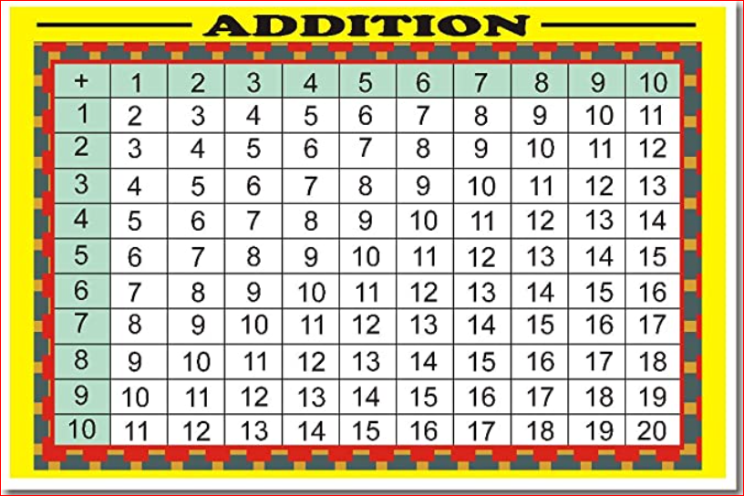

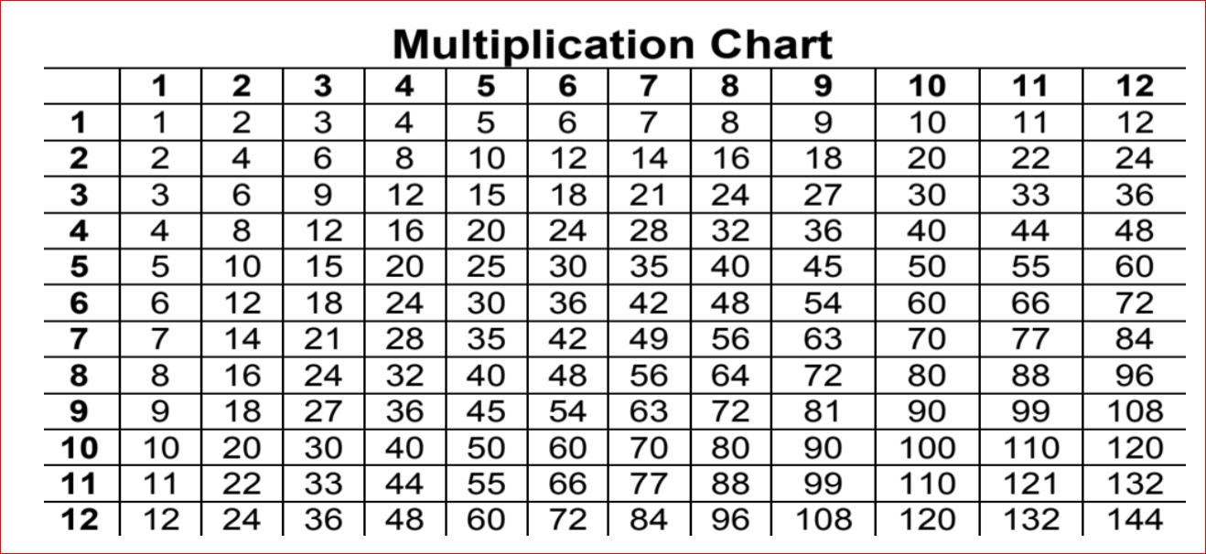

**RACES WRITING STRATEGY**

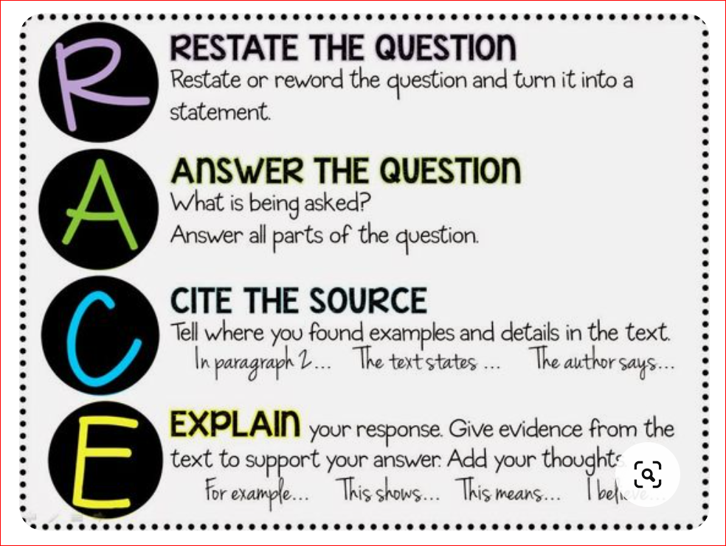

# Writing in the Margins: Six Strategies at a Glance

This table provides six strategies that help readers understand texts. While making connections, clarifying information, or doing other work defined on this page, write down your thoughts in the margins of the text, on sticky notes, or in your notes.

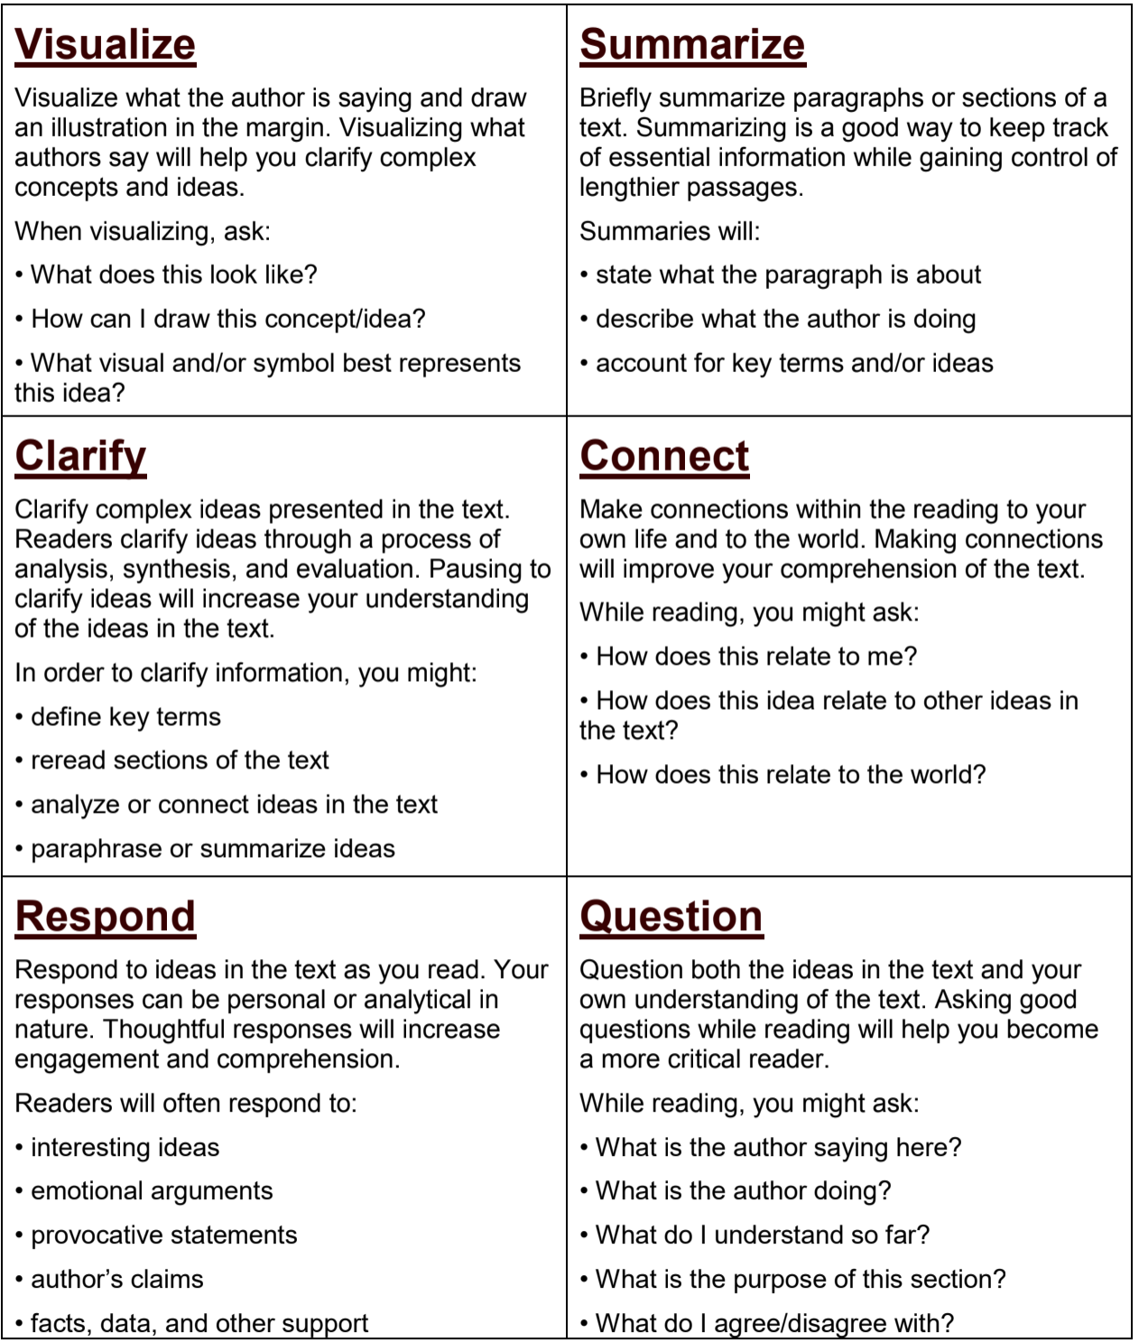

# World Map

